1. Virtual Machine Creation
A Virtual Machine was created using VirtualBox as the type-2 hypervisor platform. VirtualBox was selected for its maturity, cross-platform support, and headless operation capability, aligning with the requirement to operate without a GUI. The VM was configured with 2 GB RAM (the minimum required for a stable Arch Linux installation), default CPU settings, and a 40 GB dynamically allocated VDI disk split into multiple 2 GB files.

2. Arch Linux Installation & Disk Partitioning

2.1.Boot and pre-installation
The system was booted from the Arch Linux ISO in the live environment. As shown below, an SSH session was already available via the live environment's root account from the host machine, allowing commands to be typed and pasted conveniently. The keyboard layout was verified using localectl list-keymaps | grep gb, confirming GB keymap availability:
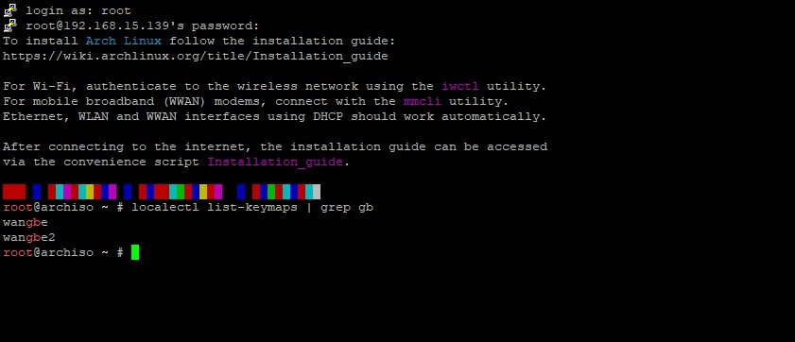
System time was synchronized using timedatectl set-ntp true to ensure package signatures would validate correctly. timedatectl status confirmed NTP service was active.

2.2.Disk Identification & Partitioning
The 40 GB virtual disk was identified as /dev/sda using lsblk. The tool cfdisk was used to create the partition layout interactively, chosen for its clear menu-driven interface over fdisk's raw command mode, reducing the risk of partitioning errors on a production server:
Three primary partitions were created to exactly meet the specification: /dev/sda1
(512M, /boot),
/dev/sda2 (14G, /home), and /dev/sda3 (25.5G, /). After writing the partition table, lsblk confirmed the layout:
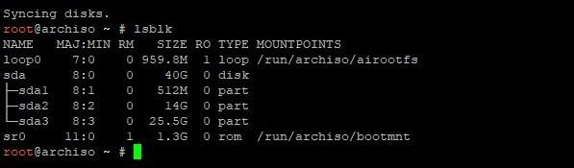

2.3.Filesystem Creation & Mounting
All three partitions were formatted with ext4, a robust journaling filesystem wellsuited to server workloads. The ext4 filesystem provides journal-based crash recovery and supports large files appropriate for a web and database server (Mathur, 2007) The mkfs.ext4 command was run on all three partitions.
Partitions were then mounted in the correct order — root first, then subdirectories — and lsblk was used again to verify all mount points were correct before proceeding with package installation:
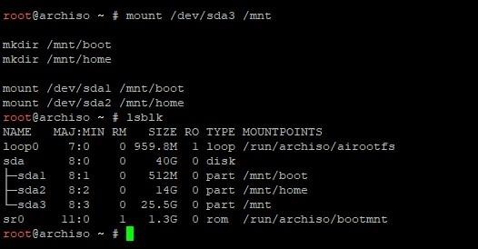

2.4.Base System Installation
Before running pacstrap, the pacman keyring was initialised and populated to ensure package signature verification. The base system, development tools, the Linux kernel, and firmware were installed via pacstrap /mnt base base-devel linux linux-firmware:
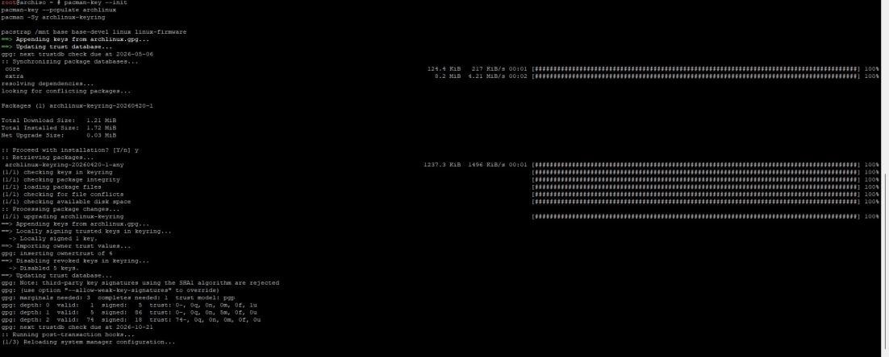

2.5.fstab, Chroot & System Configuration
The filesystem table was generated using genfstab -U /mnt >> /mnt/etc/fstab, using UUIDs for reliable device identification across reboots. The system was then chrooted with arch-chroot /mnt. Inside the chroot, vim was installed for file editing, locale (en_GB.UTF-8) was generated, the timezone was set to Asia/Kathmandu via a symlink to /etc/localtime, and the hardware clock was synchronised. The fstab contents and locale generation are shown below:
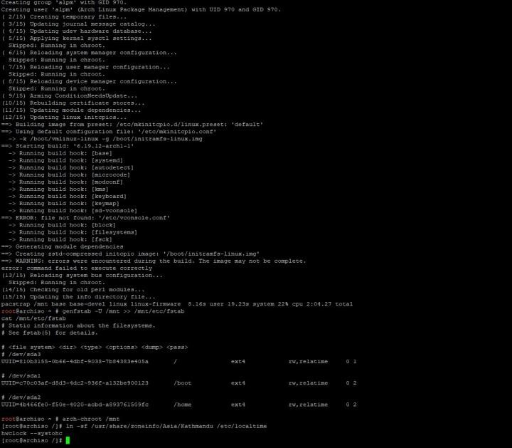
Vim was installed via pacman -S vim for configuration file editing. The locale was then generated and the locale configuration file edited. The locale list confirming en_GB.UTF-8 was selected.
The hostname was set to ecogoods-server and the /etc/hosts file was configured with the appropriate loopback and hostname entries.
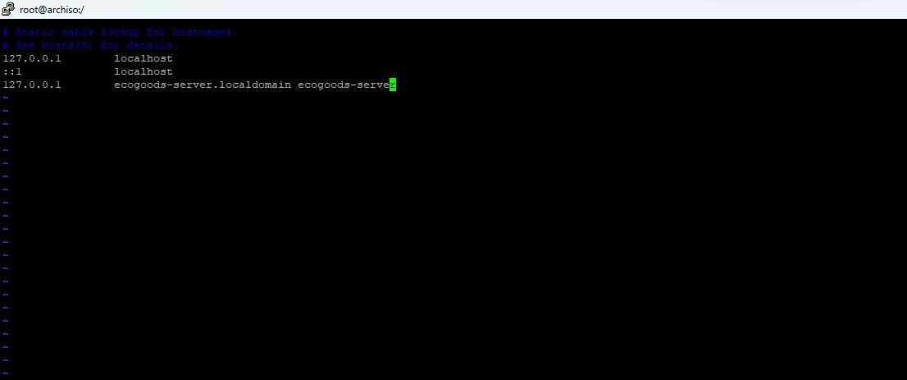
GRUB was installed as the bootloader on /dev/sda and the initial RAM disk generated with mkinitcpio -P. A root password was set via passwd before rebooting into the installed system.

3. Securing the Root Account
Direct root access represents one of the most significant security risks on a Linux server. If an attacker obtains the root password, they immediately gain unrestricted system access with no audit trail (Stallings, 2018). Two complementary measures were applied to mitigate this.

3.1.Sudo Configuration
The sudo package was installed and visudo was used to uncomment the line % wheel ALL=(ALL:ALL) ALL, granting all members of the wheel group sudo privileges. The use of visudo is critical as it validates syntax before saving, preventing lockouts from a misconfigured sudoers file:
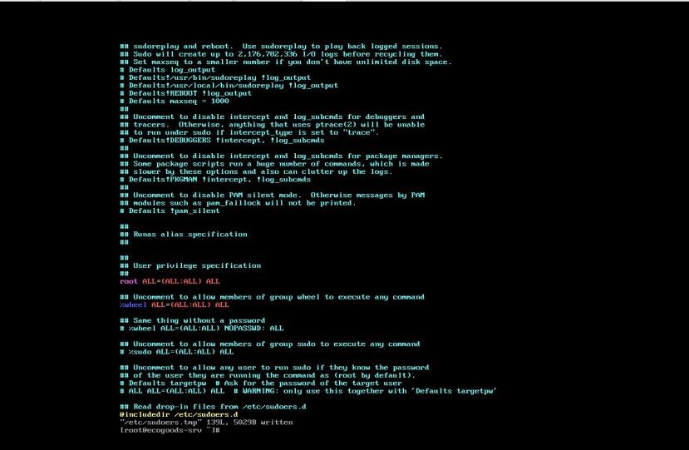

3.2.Administrative Users & Root SSH Disabled
Two administrative accounts were created sysadmin and ashley both added to the wheel group. Sudo access was immediately verified by switching to the sysadmin account and running sudo whoami, confirming it returned root:
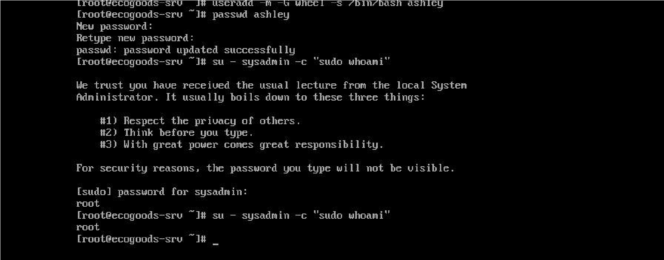
Root SSH login was disabled by modifying /etc/ssh/sshd_config using sed to set
PermitRootLogin no. This was verified with grep PermitRootLogin
/etc/ssh/sshd_config. Additionally, the root account password was locked using passwd -l root, and the shadow file was inspected to confirm the password hash was prefixed with !, indicating a locked account. All administrative tasks must now be performed via named accounts with sudo, providing a complete audit trail:

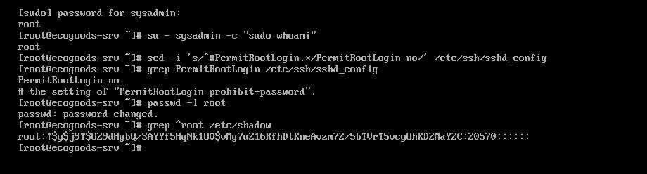

4. User Account Configuration
A group-based access model was adopted to separate concerns clearly and allow filesystem permissions to be set by group rather than individual users, simplifying future administration. Three groups were created:
developers – for Avery (Technical Lead) and Evelynn (Web Developer); testers for James (Software Tester) webdev – specifically for web file access, used to scope Evelynn's permissions to /srv/http without granting access to all developer resources.
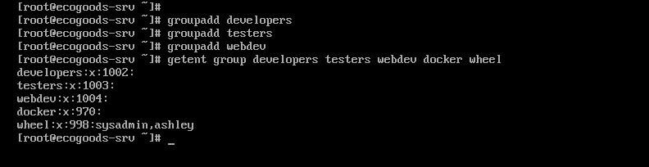
The three non-administrative users were then created with appropriate group memberships and shells. Avery, as Technical Lead, was added to developers, webdev, and docker groups with an interactive Bash shell. Evelynn was assigned /usr/sbin/nologin as her shell, preventing interactive logins while still permitting
SFTP file transfers — appropriate as she does not require CLI access (Saltzer & Schroeder, 1975). James was given an interactive Bash shell and added only to the testers group. The id command confirmed all group assignments

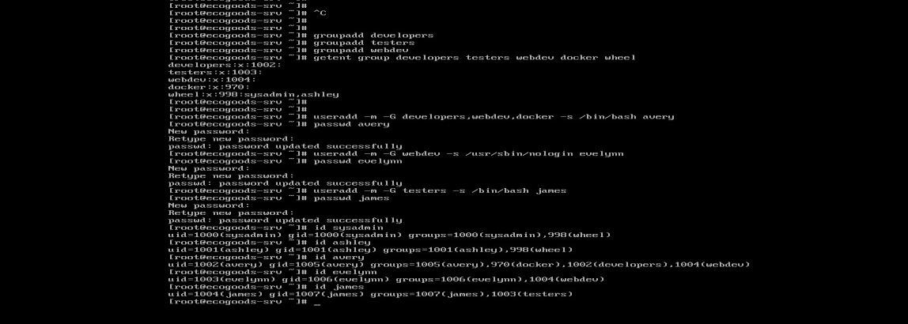

5. SSH Server Configuration
OpenSSH was installed and hardened via /etc/ssh/sshd_config: root login and password authentication were disabled, with Ed25519 public key authentication enforced (Bernstein, 2012). An explicit AllowUsers whitelist and MaxAuthTries 3 further restrict access. Configuration was validated with sshd -t before restarting. Evelynn was restricted to SFTP-only via a Match User block using internal-sftp, preventing shell access.

6. Docker Installation & Containerization
Docker was installed via pacman -S docker docker-compose and enabled as a systemd service. Only Avery, sysadmin, and ashley were added to the docker group, restricting container lifecycle management following least privilege (Saltzer, 1975). MySQL was attached exclusively to the internal network with no host port bindings. PhpMyAdmin and Nginx bridge both networks, with Nginx exposed on port 80 serving /srv/http and proxying /phpmyadmin/ (Kane, 2023) A dedicated dbadmin MySQL user was provisioned for Avery via environment variables.
Decision | Rationale
MySQL on internal network only | Meets spec: not externally accessible, only by other containers
PhpMyAdmin behind Nginx reverse proxy | Meets spec: accessible via /phpmyadmin route
Nginx on port 80 | Meets spec: accessible on Port 80
Docker group restricted to  Avery/admins | Least-privilege principle — testers cannot affect container lifecycle
dbadmin MySQL user for Avery | Meets spec: Avery requires a database admin user

Configuration was verified using docker ps confirming all three containers running, docker inspect mysql confirming no host port bindings, curl http://localhost returning the EcoGoods page, and curl -I http://localhost/phpmyadmin/ returning HTTP/1.1 200 OK confirming the reverse proxy was functioning correctly.

7. Development Directory & File Permission Configuration
A group-based access control model was adopted for /srv/ following the principle of least privilege (Saltzer, 1975). Ownership of /srv/dev was assigned to the developers group with the setgid bit (chmod 2770) to prevent permission drift. POSIX ACLs granted the testers group read-only access (r-x), allowing James to inspect code without modifying it. For /srv/http, the webdev group was assigned for Evelynn's SFTP uploads, with an additional ACL granting Avery full access across all /srv/ directories as Technical Lead. Permissions were verified using getfacl and tested by switching between user accounts, confirming all access controls behaved as intended.
setfacl -R -m g:testers:r-x /srv/dev setfacl -R -d -m g:testers:r-x /srv/dev

setfacl -R -m u:avery:rwx /srv/http setfacl -R -d -m u:avery:rwx /srv/http
Test | User | Expected | Result
Write to /srv/dev | avery | SUCCESS | SUCCESS
Read /srv/dev | james | SUCCESS | SUCCESS
Delete from /srv/dev | james | BLOCKED | BLOCKED (write-  protected)
Write to /srv/http | evelynn | N/A (nologin shell) | Account not available — correct
Write to /srv/http | james | BLOCKED | Permission denied —  BLOCKED

9. Appendix

Appendix a


Appendix b
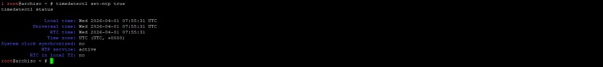

Appendix c
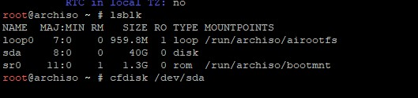

Appendix d
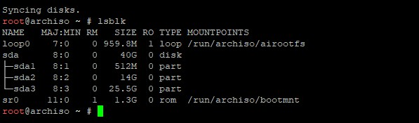

Appendix e
